**MINI PROJECT (GROUP: 6)**

**TOPIC -** TEMPERATURE BASED AUTOMATIC FAN SPEED CONTROL SYSTEM

**MEMBERS**:

1. AMRIT TRIPATHI
2. MOITREESH SAHA
3. RISHIDEO RAJ
4. D ARAVIND

**AIM**: To create a system for controlling fan speed based on changing surrounding temperature

**PROGRESS**:

In our previous semester, we prepared our detailed report based on our research on the variation and control of speed of fan using a temperature sensor and a micro-controller. We had the inspiration of making this project when we wanted to automate the fan to change its speed according to the surrounding temperature and hence reduce the efforts for people who are physically challenged and senior citizens. In this effort we tried to implement this idea first on a smaller scale. Hence, we designed circuit for a small 12V DC Fan Motor. But in our future scope we mentioned to further implement this idea to a daily use household fan.

In our progress, we have done our initial research on creating a circuit using the same temperature sensor and controller and applying to an AC Fan motor. In our thought process and research, we found out that the AC system circuit will be different from the DC Fan system. Hence, we learnt more about the components or changes that we may need to make to upgrade our project from DC to AC system. These progress aspects are divided into 3 parts – A, B and C.

1. The extra components that are required are:
2. **Transformer**: Since in our circuit we had a DC supply and our micro-controller works on a low voltage DC supply, we need to convert the output signal from DC to AC and supply it to the AC fan motor. It is a crucial step while converting the output signal and henceforth we must implement a transformer in the circuit that will give us right AC output signal.

Also, we may require to step up or step down to Direct supply to match the rated voltage of the AC Fan motor. Here two options arise. Either we,

1. Step up the DC signal coming into the Arduino and apply it to the transformer that in turn supplies it to the AC Motor or,
2. We take the AC signal from our home supply and feed it to the fan while providing a separate 5V DC supply to the Arduino to perform its operations.

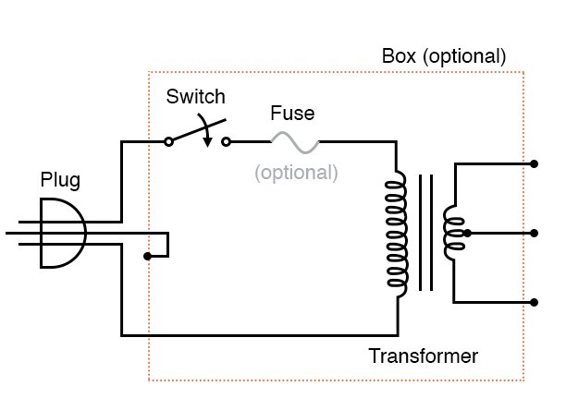

1. **Triac**: Since we are working with a AC signal which changes polarity and is half the times ON and half the times OFF, we need to now figure out the time for which the signal is in off state and we have to control the amount of timing for which the power will be ON and OFF. For this a Triac is used. It is a three-terminal AC switch that can be triggered by a low energy signal at its gate terminal. In TRIAC, the power can be controlled in both directions.

Thus, we need to modify the circuit accordingly.  Our output [PWM signal](https://circuitdigest.com/tags/pwm) will decide the amount of voltage output to the AC motor, which in turn controls the speed of it. TRIAC, controls the AC voltage as it is a power electronic switch for controlling an AC voltage signal.

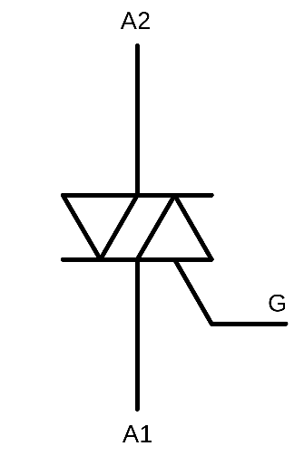

1. Next, we tried to do more research on the simulation part of our circuit.

We have studied how to simulate using simulation software like Tinker Cad and we will implement the design on software first and see the results and the characteristics of the behavior of our circuit. Then we will see how the speed behaves according to change in surrounding temperature and find out how we can further improve our circuit design.

If the circuit is possibly converted to the AC circuit, we will simulate it and study the difficulties that we may face and the problems that may occur. We will also draw graphs on how to extra components we have added will affect the output signal and voltage.

1. We have discussed and tabulated our project budget and the following things are listed according to our previous report and circuit design for automatic speed control of DC Fan.

|  |  |  |  |
| --- | --- | --- | --- |
| COMPONENTS | UNIT | UNIT RATE | COST |
| Arduino Uno (R3) | 1 | Rs 621 | Rs 621 |
| 16x2 LCD display | 1 | Rs 227 | Rs 227 |
| LM35 Temperature Sensor | 1 | Rs 250 | Rs 250 |
| Breadboard + Jumper wires | 1 | Rs 222 | Rs 222 |
| Resistor (1kΩ) | 2 | Rs 10 | Rs 20 |
| NPN Transistor (2N222) | 1 | Rs22 | Rs22 |
| DC Motor (12V-24V, 10K-20K RPM) | 1 | Rs 339 | Rs 339 |
| Diode (1N4007) | 1 | Rs 4 | Rs 4 |
| Capacitor (10µF) | 1 | Rs 4 | Rs 4 |
| Battery (12V DC, 12A) | 1 | Rs 1890 | Rs 1890 |
| TOTAL PRICE | | | Rs 3599 |

**THE PROJECT BUDGET:**

This is not our final budget list. We are planning to add a few in future to upscale to project. This a rough estimation of the cost that is required for that hardware build of our project system.

**ACKNOWLEDGEMENT**:

Our sincere thanks to Professor Dr. AMAL BARMAN for guiding us and delivering help in our project and research.